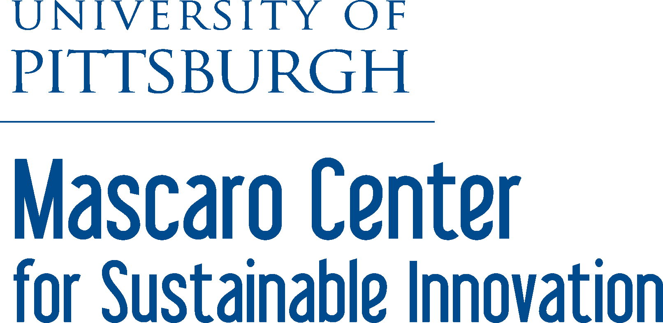
2017 Undergraduate Summer Research Program

Water desalination through reactive extraction
Madeleine Hamrick, chemical & petroleum engineering
Advisor: Eric Beckman, chemical engineering

Pittsburgh Water Microbiome
Austin Kuntz, bioengineering
Advisor: Kyle Bibby, civil & environmental engineering

Additive manufacturing of energy-saving and energy producing materials
Colleen Hilla, materials science & engineering
Advisor: Markus Chmielus, mechanical engineering & materials science

Development of Next Generation Nano-Antimicrobials
Cole D’Aurizio, mechanical engineering
Advisor: Leanne Gilbertson, civil & environmental engineering

Unlocking energetically efficient water oxidation for ozone disinfectants
Angela Leo, chemical & petroleum engineering
Advisor: John Keith, chemical & petroleum engineering

Machine Learning Blueprints for Green Chelating Agents
Ethan Henderson, chemical & petroleum engineering
Advisor: John Keith, chemical & petroleum engineering

Black silicon etching for solar cells
Maxwell Lindsay, materials science & engineering
Rafael Rodriguez, materials science & engineering
Advisor: Paul Leu, industrial engineering

Electrochemistry for sustainable energy conversion and storage
James Hughes, chemical & petroleum engineering
Dean Miller, chemical & petroleum engineering
Advisor: James McKone, chemical engineering

Integrating Sustainable Design in Engineering Education
Kaleigh Smith, mechanical engineering
Advisor: David Sanchez, civil & environmental engineering

Desalination using polymer crystallization
Joseph Hamm, chemical & petroleum engineering
Advisor: Sachin Velankar, chemical engineering

Feeding a Growing World: Towards a Novel Process for Ammonia Synthesis
Eric McElhinny, chemical & petroleum engineering
Kendra LaVallee, chemical & petroleum engineering
Advisor: Goetz Veser, chemical & petroleum engineering

Automated growth of two-dimensional materials for green electronics
Joji Bronner, computer engineering
Advisor: Feng Xiong, electrical and computer engineering

2-D and nanomaterials for Energy Applications
Connor Herring, chemical & petroleum engineering
Advisor: Minhee Yun, electrical and computer engineering

