Impactful Resilient Infrastructure Science and Engineering
(IRISE)
-Project Scope of Work-
(FY 2023-24 (IRISE Year 6) Annual Work Program)

SUMMARY PAGE
Project Title: Supervised Learning for Classification of High-Resolution LiDAR Point Clouds

Person Submitting Proposal: Dr. Alessandro Fascetti

Proposed Funding Period: February 1, 2024 - January 31, 2026

Project Duration: 24 months

Project Cost: $160,588.76

Project Title: Supervised Learning for Classification of High-Resolution LiDAR Point Clouds
Problem Statement: LiDAR technology has dramatically changed the way surveying of large-scale civil infrastructure projects are planned and performed. High-density scans have seen a steady increase in attention and use cases over the last decade because they are relatively easy to use and can geo-reference large-scale models by incorporating survey data. Moreover, recent technological advancements have allowed the superimposing of RGB classification (i.e., color information obtained from digital camera sensors) on the laser-based reconstructions (point clouds), which greatly helps in the visualization and interpretation of the field data, by allowing the technician to differentiate objects in the field like edge of pavement, tree lines, cars, and structures which often are difficult to pick out from the default intensity classification. More recently, the classification workflow of selecting and assigning areas of a point cloud has been updated using algorithms to automatically classify point cloud data into specific regions. However, this technology has not yet been widely adopted in civil engineering projects because the workflows required to extract the specific information of interest from the laser-based data are very complex. The main challenge lies in the formalization of tools to translate the 3-dimensional point cloud information into structural design and assessment (e.g., FEM analysis or asset management software), at the level of the single structural components. Available tools, in fact, require human operators to classify the point clouds manually, which is labor-intensive and inefficient. Even though the sensibility of a human operator is required to correctly interpret unique features of the specific site object of investigations, there exist several opportunities to increase quality and efficiency of the associated workflows, thanks to modern 3-dimensional computer vision techniques developed in the last decade.
Project Objectives: Main objective of the proposed research is to improve accuracy and efficiency of surveying operations, ultimately paving the way for novel 3-D project delivery workflows. This requires the development of novel classification tools for the supervised segmentation of 3-dimensional point clouds by combining digital models, a comprehensive database of laser-based reconstructions, and computer vision libraries such as OpenCV, Scikit-Image, and TorchVision (which will be critically identified in Task A). We will take a Supervised Learning approach in the delivery of the project, to directly include expert knowledge in the classification algorithms. This will be achieved by classifying available point clouds (Task B) and using this information to devise infrastructure-specific segmentation algorithms (Task C). The ultimate objective is the preparation of a report (Task D) and a set of guidelines (Task E) to maximize outreach and direct applicability of the research.

Project Scope: In this project, we will create novel software tools to classify dense LiDAR point clouds obtained from terrestrial and/or aerial surveying of civil infrastructure. This project will specifically focus on horizontal infrastructure applications; therefore, we will be investigating bridge and pavement data that is already available to the PI through the IRISE consortium members. This will allow us not only to coordinate and execute the project quickly and efficiently, but also to provide results that are directly applicable to stakeholders in Pennsylvania (particularly, IRISE members).
We will investigate two approaches: (1) training of machine learning-based techniques to classify the entire 3D scene, and (2) adoption of camera-based classification on multiple 2-dimensional views obtained from the 3-dimensional models. This choice was made because currently available 3-dimensional computer vision algorithms need to be trained on extensive datasets of annotated data. In particular, annotating laser point clouds (i.e., marking the different classes each point corresponds to) is labor-intensive, generally prohibitive to perform, and prone to human error. Camera-based classification based on 2-dimensional computer vision, however, brings the potential for leveraging available computer vision models, such as VGG19 and GoogleNet.
Moreover, we will formally quantify the increase in classification accuracy provided by the inclusion of RGB information in the analyses, since this information is crucially important for surveying. The ultimate goal of the research is to construct novel processing capabilities to serve as an explanatory step in-between the registration of the point clouds and the import into specialized civil engineering design software. The derived algorithms will be leveraged to segment the original point cloud, identifying the main structural elements and classifying each point in the cloud, assigning the appropriate class. In such a way, the process will not yield a reduced (i.e., decimated) point cloud, therefore resulting in no loss of resolution.

Task Statements
The objectives of this project will be realized through the completion of the following tasks:
Task A: Review of current practices in point cloud segmentation
Current practices in LiDAR point cloud post-processing and segmentation will first be reviewed to identify the state of the art in classification of dense 3D scenes and extraction of the relevant geometrical features. We will also investigate available tools and workflows to perform data transfer between the point cloud processing software and the relevant engineering analysis tools.
Task B: Training on 2- and 3D annotated data
In this task, we will leverage the information obtained in Task 2, both the available 2-dimensional computer vision techniques and the synthetic annotation of 3D point clouds, to create a new dataset specifically for horizontal infrastructure applications. Two models will then be trained with this data: (1) a 3-dimensional tool based on semantic segmentation; and (2) a 2-dimensional computer vision tool trained on planar representation of the environment, which will be directly obtained by sectioning the point cloud along longitudinal and transversal directions.
Task C: Development of segmentation algorithms
The model trained in the previous task will then be exercised on the available data. In particular, we will compare results of the two proposed approaches with a suite of selected point clouds, which will be manually annotated by the research team and represent the ground truth information to be used in the quantitative assessment of the performance of the proposed method. We will perform several iterations of the validation study, as well as compare results obtained in this step with other methods previously proposed in the literature, to shed light on best practices in point cloud segmentation.
Task D: Draft final report
A draft final report containing suggestions and guidelines for best practices in the segmentation of 3-dimensional laser point clouds will be prepared. Such guidelines will define the optimal levels of resolution to be used in both the data acquisition and processing as a function of the specific structures being examined (e.g., bridges or pavements), as well as the required level of human intervention throughout the process.
Task E: Final Report
A final report, taking into consideration comments that were received on the draft final report, will be prepared.

Deliverables:
- Task A: Literature review of existing algorithms for point cloud segmentation will be submitted to the IRISE and the PennDOT Research Project Manager within 6 months from the Notice to Proceed date.
- Task B: Database consisting of 2- and 3-dimensional annotated scenes will be submitted to the IRISE and the PennDOT Research Project Manager within 14 months from the Notice to Proceed date.
- Task C: Pre-trained model and validation results will be submitted to the IRISE and the PennDOT Research Project Manager within 21 months from the Notice to Proceed date.
- Task D: Draft final report will be submitted to the IRISE and the PennDOT Research Project Manager within 23 months from the Notice to Proceed date.
- Task E: Final report and recommendations will be submitted to the IRISE and the PennDOT Research Project Manager within 24 months from the Notice to Proceed date.
Upon completion, deliverables will be submitted to PennDOT.

Budget Notes
Key Personnel:
Principal Investigator:
Alessandro Fascetti, Ph.D.

Other Personnel:
Grad Students:
To Be Named Graduate Student Researcher

Undergrad Students:
To Be Named Undergraduate Student Researcher

Proposed Person-Hours by Task:

Team Member | Task A | Task B | Task C | Task D | Task E | Total
Key Project Team Members, Estimated Hours Per Task
Alessandro Fascetti | 60 | 120 | 90 | 60 | 30 | 360
Graduate Student | 554 | 1109 | 832 | 227 | 50 | 2772
Undergraduate Student | 100 | 230 | 320 | - | - | 650
Total | 714 | 1459 | 1242 | 287 | 80 | 3782

Schedule:
Calendar Year | Year 1 |  |  |  | Year 2
Quarters | Q1 | Q2 | Q3 | Q4 | Q1 | Q2 | Q3 | Q4
Task A: ~5 months
Task B: ~9 months
Task C: ~14 months
Task D: ~3 months
Task E: ~3 months

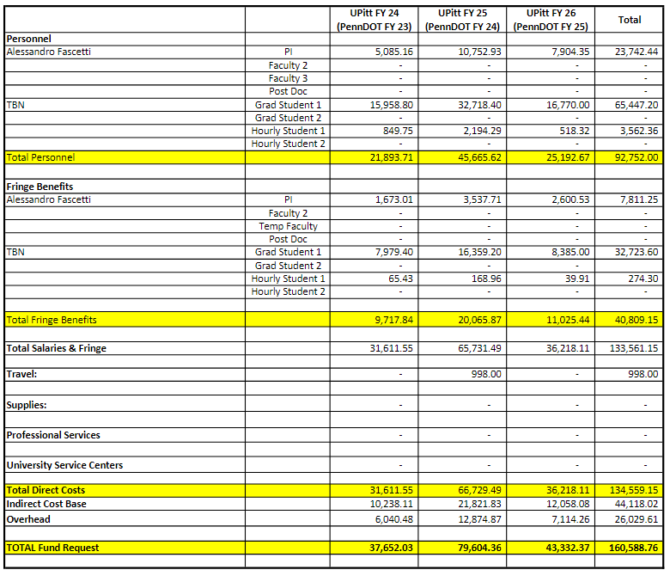
Budget: The total project cost is $160,588.76

Acknowledged By:

Alessandro Fascetti, Ph.D.
Principal Investigator

