Hysitron Tribo-indenter
Basi operation instruction (Indentation)
Overview of the component
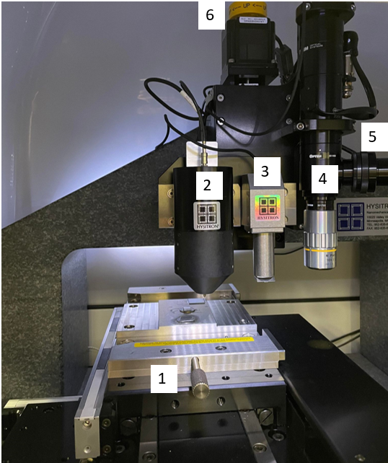 | - Magnetic sample stage  - High Load transducer  - Low load transducer  - Optical column  - Light source  - Manual Z-axis knob

- Starting the machine and software
- Setting up the sample
- a. Calibration the indentation axis by performing an air indent: Low load
b. Calibration the indentation axis by performing an air indent: High load
- Defining the sample
- Tip-to-optic calibration
- Performing Indent
- Data analysis

All hardware can be left turned on except for the light source.

1. Starting the machine and software
- Turn on the light source.
- Open the software .
- If you are using the tool for analysis only, click on the Analyze button when prompted.
Otherwise, let the timer run out or click Cancel and allow the program to continue to boot up.
- Select the right transducer in the box. Click OK.
- The program will start every session by homing all three axes ( Z axis, Y Axis then X axis) and performing transducers checks. This will take a few minutes.
2. Setting up the sample
- The sample surface must be parallel to the sample bottom. Avoiding using 2 samples at once especially if they are of different heights.
- If the sample is not ferromagnetic, it must be glued to a small magnetic disc using super glue.
- Once the sample is secured to the disc, it is ready to be placed onto the magnetic stage.

3. Calibration the indentation axis by performing an air indent (Low load transducer):
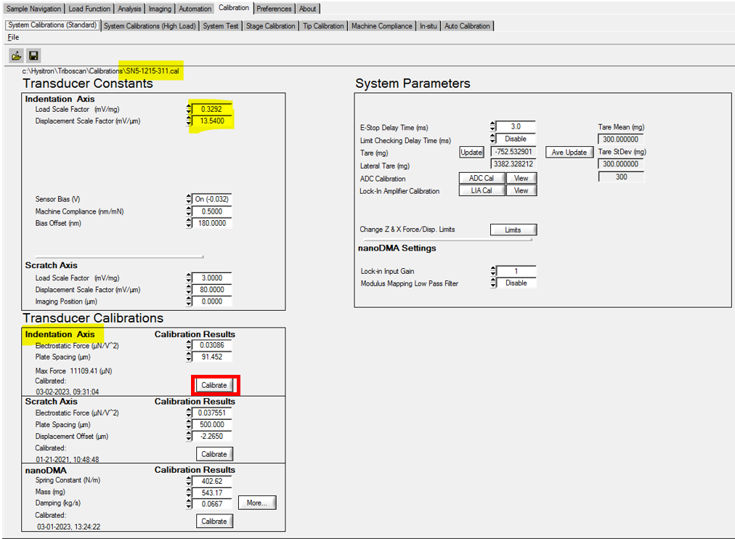
- Under the “Calibration” tab, “System Calibrations (Standard)” sub-tab, look for the box labelled “Indentation axis”. Click the “Calibrate” button in that box. See image below.
- Using the default load function perform the air indentation by clicking the button in the lower middle section of the window labelled “Cal. Air indent”. (Peak load 1411)
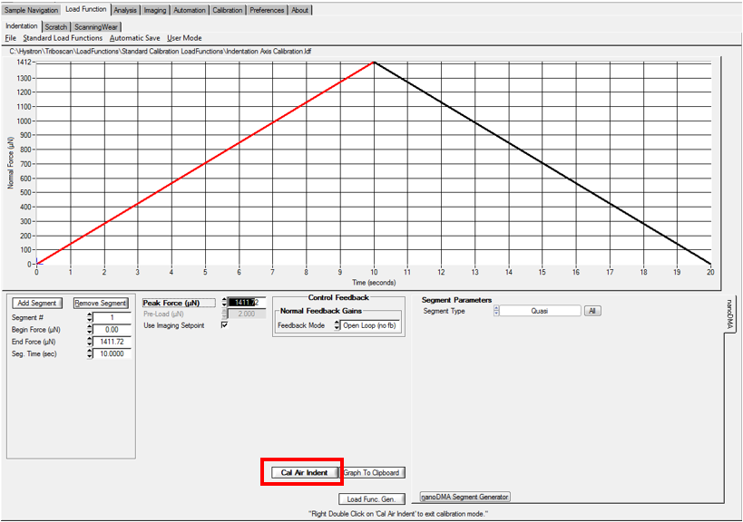
- “Single indent” box will pop up. 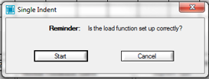. Click “Start”.
- Check the successful air indentation calibration.
1. The liner fit in the EFS vs Displacement graph and 2. RMSE value below 5e-5 uN. 3. EFS vs Displacement graph should not have a range greater than 3-5 um (for the lower load transducer).
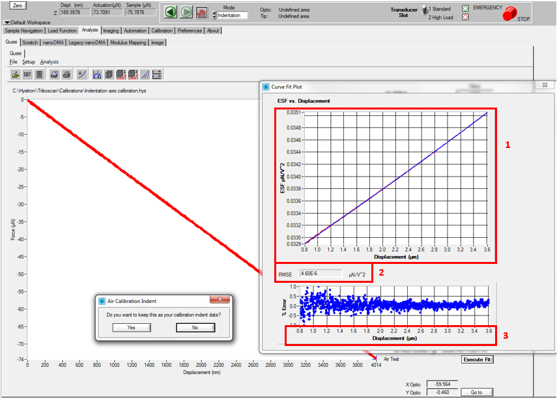
- Click Yes if you want to save the result.
- Close the curve fit plot box.
- The Force-Displacement data will be flattened and look flat or slightly concave up or down.

Overview of the Sample Navigation
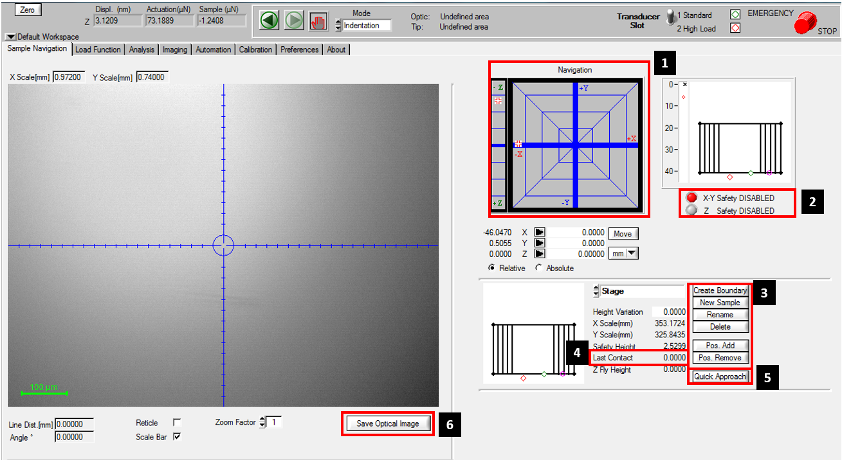

- Sample navigation: The farther away from the center of the XY or Z center, the faster the motion. For Z, clicking and holding below the center line moves the stage up. Avoid rapid clicking in the navigation areas, this can crash the software. Movement should be accomplished by clicking and holding.
- Safeties: When illuminated red, the safeties are disabled.
- Sample area creation buttons. Clicking “create boundary” will create a sample area in the current optical view on the left.
- Last Contact
- A quick approach must be performed so that the tip knows how far it can move down before contracting the sample.
- To save the image of the current optical location.

4. Defining the sample
- Click on “Sample Navigation”. In the upper right of the “Sample navigation” tab, there is a gray box with crosshairs. To move in some direction, click and hold in the area to move along the x-y plane. To the left of this box is a smaller rectangle for movement along the Z-axis, same movement principle as the x-y sections. Use this to focus on the sample.
- Click on “X-Y Safety DISABLED” option (Red) and align the sample under the optics light, then click again on the “X-Y Safety DISABLED” to re-enable the safety (Gray).
Focus on the sample, click on “Z Safety DISABLED” option (Red), CAREFULLY move on Z axis until focus, then re-enable the Z safety (Gray). Be careful!!!,
- When you can focus on the sample, try to find edge of the sample area.
- Click on “New Sample” to create the boundary using box 3.
- Find the starting point near the edge of the sample. Click Pos Add (button located in the box 3)
- Choose the second point using X or Y direction Crosshair and Click Pos Add.
- Create an area in this way. Once you have defined a sample area, right click within the area in the overview map. Remember to leave the safeties gray for both ‘X-Y Safety DISABLED’ and “Z Safety DISABLED” options.
- See below image.
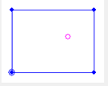
Note: No testing can be performed outside of this area. To test outside of this area, define a new boundary.
- Click “Save optical Image” to save the image of the current optical location.
- Don’t use Zoom factor. (Currently, the microscope is slightly out of alignment.)

5. Tip to optic calibration
- Go to Calibration in the main menu and choose Stage calibration in subtab.
- Click on located below the image.
- Choose H pattern option 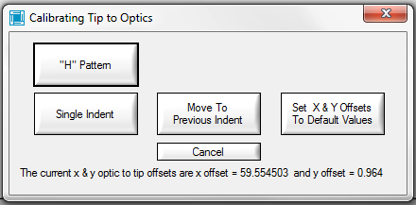.
- 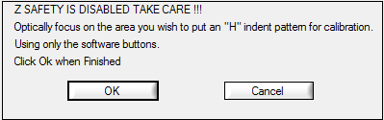 , then click OK.
- Select the displacement 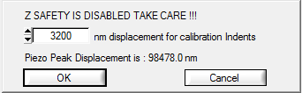, then click OK.
- “Moving the tip over the sample” box will pop up.
- Use the Z navigation control manually to move the tip down to approximately 1 mm above the sample. Be careful!!!
- Then click OK.
- “Calibration H pattern box is in progress which will take about 12 mins.
- A few windows will come up and close themselves during the process.

6. Performing Indent
Note: Samples must be defined in the software before a test can be performed. If your sample is not defined, the software will not let you perform and indentation.
- If the last content value is zero (Box 4), then click on Quick approach (button in box 5) to perform a quick approach and to define the precise height of the sample. Make sure your sample has a last contact value saved.
- Wait for quick approach process about 1-2 mins.
1. Prior to performing the indent, you will need to open the correct load function. This is a 5-2-5 (5-seconds to peak load, 2-second hold, 5-second unload) profile. Go to the Load function tab, Subtab Indentation comes up, click on Standard Load Functions and choose Basic QS Trapezoid.
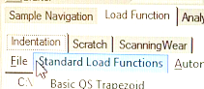
2. Set-up or choose your loading profile in Peak force, do not exceed the maximum load for the current transducer (the software will correct overloads before they can be performed)
Note: Peak force can be altered using Peak Force box or the left box. To edit the segment, enter the number in the Segment box or click on the curve in the plot. (Active segment will light up, red.)
3. Choose Load controlled in Feedback Mode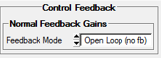 which is in the middle of the screen.
4. Click on “Perform Indent” (Wait for 1 min).
After hitting perform indent, the tip will move over the sample and allow for the motors and piezo to settle (Approximately 105 Sec). 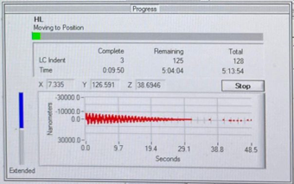.
After the settled time, a drift correction box will be done, then the indent will start. A few windows will pop up and close themselves during the process.
7. Data analysis
After performing an indent, the analysis tab will be automatically opened. See the image below.
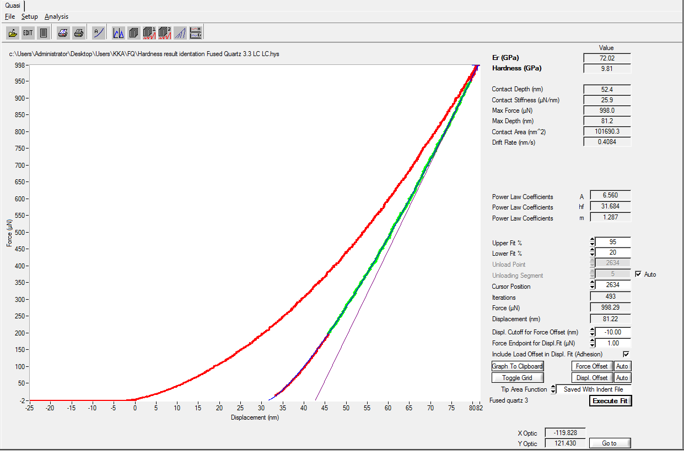
1. The software will prompt you for the filename under which to save the data.
2. Once the analysis screen is opened, click ‘execute fit’ in the bottom right of the screen. This will fit the unloading curve and fill in all of the zero values above. If the unloading curve has an abnormal shape, the region that is fitted (shown in green after clicking execute fit) can be altered by changing the ‘upper’ and ‘lower’ fit values. Re-execute fit after changing these value.
3. Text data contained force, time and displacement can be easily be exported by clicking ‘file’> ‘export text file’. The software will ask if you want ‘ load segment separated printout’. The only difference between checking yes and no is that the output looks a bit cleaner in notepad. Both can easily be read by matlab, pythonand excel.
Calibration the indentation axis by performing an air indent (High load transducer):
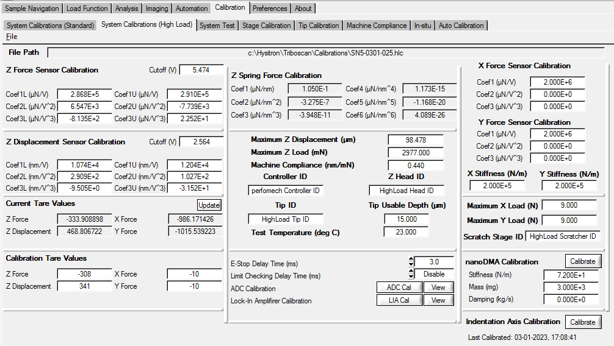
- Under the “Calibration” tab, “System Calibrations (Standard)” sub-tab, look for the box labelled “Indentation axis”. Click the “Calibrate” button in that box. See image below.
- Using the default load function perform the air indentation by clicking the button in the lower middle section of the window labelled “Cal. Air indent”. (Peak Displacement 96508.44nm) 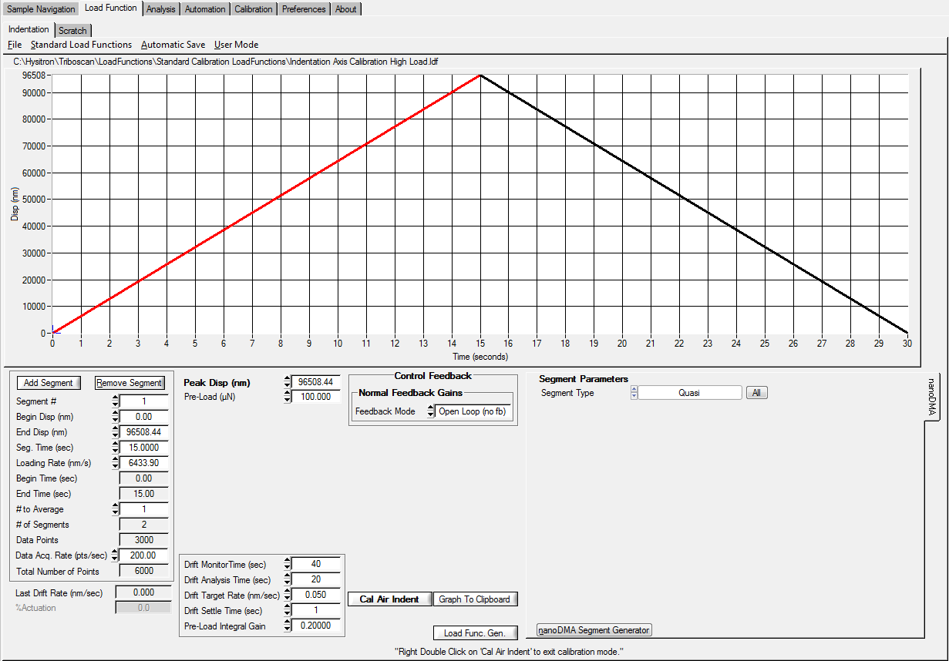

- “Single indent” box will pop up. . Click “Start”.
- Check the successful air indentation calibration.
- RMSE value below 20 μN for the high load transducer.
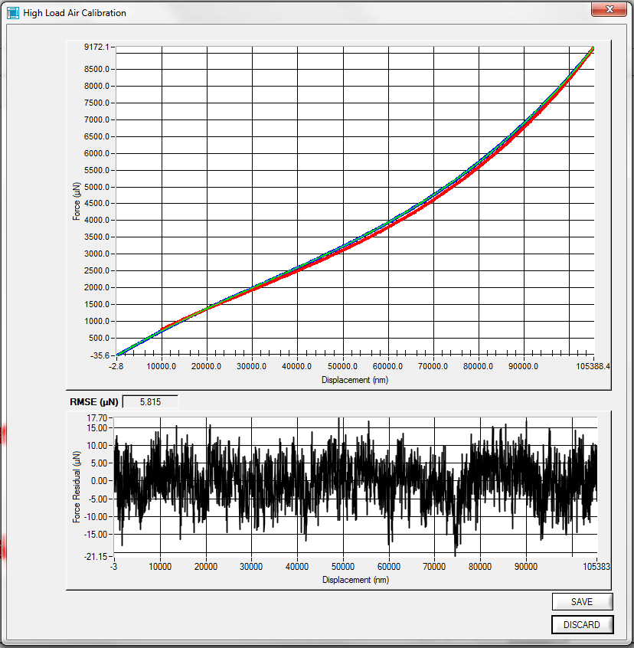
- Click Save if you want to use the result.
- Close the curve fit plot box.

