Profilometer-Keyence
Basic operation instruction
Warning:
- Make sure there is no object on the scanning stage before setting up the microscope.
- After measuring, don’t forget to turn off the microscope and log out from the FOM.

OPERATION PROCEDURE
a. Starting the microscope
Log in to FOM.
Ensure that there is no object on the scanning stage before setting up the microscope.
- Open the VR-3000 software.  - Switch on the microscope stand.  - Click on Viewer. | 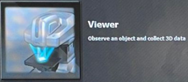
- The box will come up the screen and click Yes to return the stage to the XY and Z origin (Wait for 30sec). | 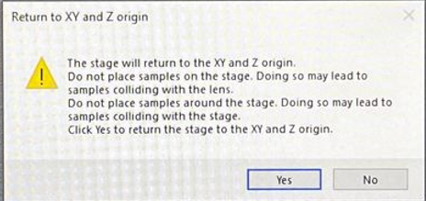
b. Setting up the sample
- Place the sample on the scanning stage.
- Adjust the sample position under the microscope- Manually or use ‘Mouse operation box’ for XY directions.
- Choose AF for Auto focus OR use rotation knob of microscope for Z direction.
- You can use the tool bar to adjust the Camera brightness, View and Magnification.

c. Measuring (Acquiring) the image
- Measuring the image
- When you have a desire image, click Measure button to take your image. | 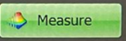
You have 3 options to continue the process.  - If you are satisfied with the image, click on Save OR click on Analyze to analyze the image.  - Click on Back to change the image. | 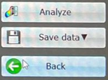
- Stitching the image
1. Select Manual for stitching  2. Click on Measure and then Register  3. Select the area that you want to continue.  4. Click on Measure and then Register  5a. If done, click on Excu Stitching and then Click on Save OR click on Analyze to analyze the image. 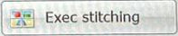  Click on Back to change the image. | 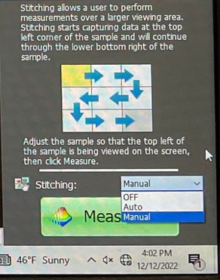
5b. If you need more, click on Continue.
Click on Specify the next measurement position and select the position.
Click on Measure and then Register.
Repeat instructions again 5a. If done, click on Excu Stitching and then Click on Save OR click on Analyze to analyze the image.
Click on Back to change the image.

d. Saving the image
Saving the data in 3 ways
- Main menu- Select Analytical template and click on Save.
- Use Operation guide on the right side of the screen—Click on Save results and Select (Report/Save as excel/Save as image/Save analysis results)
- Use Tool bar and select one (Report/Save as excel/Save image)  Recommend-  - To save each measurement, use Tool bar/ Operation guide and select Report (Save as pdf)  - To save all of your data, use Tool bar/ Operation guide and select Save as excel. When the box will pop up, check the options and then press OK . | 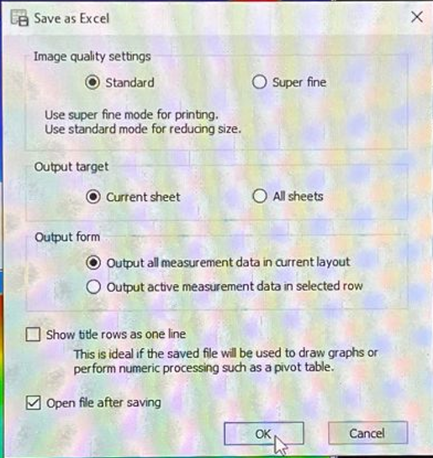
File Saving- Construct your data folder in data share folder. After your measurement, use MMCL server computer in room 532b to get your data by Flash drive. Password (532b).
e. Analyzing the image
When you get your image (after section c. Measuring (Acquiring) the image), click on Analyze.
Main data (excel file) will pop up and that includes Measurement data name, Main image (Optical & Height image), 3D image and measured date columns.
There are 3 ways to select Analyze the data.
- On Main menu, click on Measurement.
- On Tool bar, click on directly the specific tool to analyze the data.
- Operation guide- click on down arrow at Analyze data 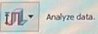.
For example: On the main menu, click on Measurement and you can see the below options
Profile measurement/Plane measurement/Average step height measurement/Volume & Area measurement/Line roughness measurement/Surface roughness measurement

Profile measurement
Click on the main optical image and click on down arrow in Analyze data to select Profile measurement.
Select the line style using Profile tools located at the top right side.
Choose the starting point and ending point (line position) on the image in Optical view.
Choose the measurement style using the Measurement tool located at the bottom right side.
Select the point/ line in Profile graph and click OK. Save as a report (Section d.4).

Note: Use the same instruction worked in Profile measure for other measurement.
Based on the measurement type, select the corresponding tool.
Average step height measurement- Choose Add an area-Select area using tools then press OK.
Volume & Area measurement- Select convex/Concav
Surface roughness measurement- Choose Add an area-Select area using tools.

f. Set measurement reference plane
Click on Reference plane setting in Operation guide and click on Specific area.
Click on Any Area and Select Reference area on the image in Optical view using tools.
g. Changing sample
For thick sample, move down the stage to get enough space between the lens and stage.
Tap on microscope icon located on the bottom task bar to view OR Go To viewer.
h. Finishing-Close the window. Take the sample from the stage.
Switch off the microscope and Log out from FOM. Check File Saving mentioned in section d to get analyzed data.

